Now we’ll start with a Home Dashboard page showing demo data first (later we’ll connect it to our database).
This page will include:
- A navbar with your project name (e.g., Student Management System we will change it later with actual navbar that will be shown to every pages. We will also footer to our website that will also be visible to every page).
- Three info cards showing:
  - Total Students
  - Departments Count
  - Recently Added Students
- Clean CSS layout using grid/flexbox.
Now change the file structures as below:
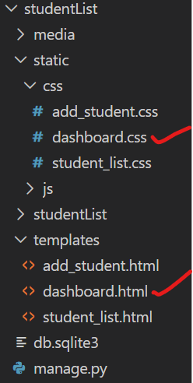
Now dashboard.html
<!DOCTYPE html>
<html lang="en">
<head>
<meta charset="UTF-8">
<meta name="viewport" content="width=device-width, initial-scale=1.0">
<title>Student Dashboard</title>
{% load static %}
<link rel="stylesheet" href="{% static 'css/dashboard.css' %}">
</head>
<body>

<nav class="navbar">
<h1>🎓 Student Management Dashboard</h1>
</nav>

<div class="container">
<div class="card">
<h2>Total Students</h2>
<p class="count" >150</p>
</div>

<div class="card">
<h2>Departments</h2>
<p class="count">5</p>
</div>

<div class="card">
<h2>Recently Added</h2>
<p class="count">3</p>
</div>
</div>

<div class="recent">
<h2>Recent Students</h2>
<table>
<tr>
<th>ID</th>
<th>Name</th>
<th>Department</th>
<th>Phone</th>
</tr>
<tr>
<td>ST001</td>
<td>Rafiul Islam</td>
<td>CSE</td>
<td>017xxxxxxxx</td>
</tr>
<tr>
<td>ST002</td>
<td>Meem Akter</td>
<td>EEE</td>
<td>018xxxxxxxx</td>
</tr>
<tr>
<td>ST003</td>
<td>Sabbir Rahman</td>
<td>BBA</td>
<td>019xxxxxxxx</td>
</tr>
</table>
</div>
</body>
</html>

Similarly copy CSS from dashboard.css
body {
font-family: 'Poppins', sans-serif;
background-color: #f8f9fb;
margin: 0;
padding: 0;
}

.navbar {
background-color: #4a69bd;
color: white;
text-align: center;
padding: 20px;
font-size: 1.5rem;
}

.container {
display: flex;
justify-content: center;
flex-wrap: wrap;
gap: 20px;
margin: 30px auto;
width: 80%;
}

.card {
background-color: white;
border-radius: 10px;
box-shadow: 0 4px 8px rgba(0,0,0,0.1);
width: 250px;
padding: 20px;
text-align: center;
transition: transform 0.2s ease;
}

.card:hover {
transform: scale(1.05);
}

.card h2 {
color: #4a69bd;
margin-bottom: 10px;
}

.count {
font-size: 2.5rem;
color: #222f3e;
font-weight: bold;
}

.recent {
width: 80%;
margin: 40px auto;
}

.recent h2 {
text-align: center;
color: #333;
margin-bottom: 15px;
}

table {
width: 100%;
border-collapse: collapse;
background: white;
box-shadow: 0 3px 6px rgba(0,0,0,0.1);
}

th, td {
padding: 12px;
border-bottom: 1px solid #ddd;
text-align: center;
}

th {
background-color: #4a69bd;
color: white;
}

Add following function to views.py
def dashboard(request):
return render(request, 'dashboard.html')

Now add the path to urls.py
path('', views.dashboard, name='dashboard'), # Map the root URL to the homePage view

Now Run the Server you will get following page as home page with full of dummy data.
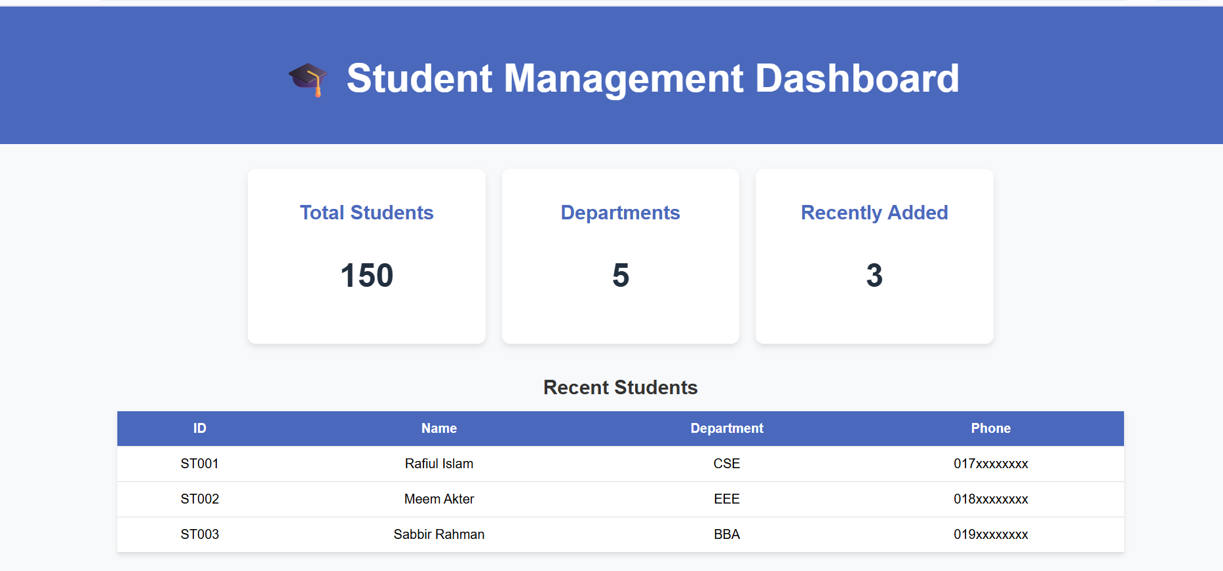

Now let’s make our Dashboard page dynamic — meaning, all the counts and recent student data will automatically come from your database instead of demo values.
Now update the dashboard() function in views.py as below:
def dashboard(request):
# Fetch all students
students = Student.objects.all()
# Total count
total_students = students.count()
# Unique department count
department_count = students.values('department').distinct().count()
# Get last 5 recently added students
recent_students = students.order_by('-id')[:5]
recent_students_count=recent_students.count()

context = {
'total_students': total_students,
'department_count': department_count,
'recent_students': recent_students,
'recent_students_count':recent_students_count
}
return render(request, 'dashboard.html', context)

Remove the dummy data from the dashboard.html file and rewrite the html file as below:
<!DOCTYPE html>
<html lang="en">

<head>
<meta charset="UTF-8">
<meta name="viewport" content="width=device-width, initial-scale=1.0">
<title>Student Dashboard</title>
{% load static %}
<link rel="stylesheet" href="{% static 'css/dashboard.css' %}">
</head>

<body>

<nav class="navbar">
<h1>🎓 Student Management Dashboard</h1>
</nav>

<div class="container">
<div class="card">
<h2>Total Students</h2>
<p class="count">{{total_students}}</p>
</div>

<div class="card">
<h2>Departments</h2>
<p class="count">{{department_count}}</p>
</div>

<div class="card">
<h2>Recently Added</h2>
<p class="count">{{recent_students_count}}</p>
</div>
</div>

<div class="recent">
<h2>Recent Students</h2>
<table>
<tr>
<th>ID</th>
<th>Name</th>
<th>Department</th>
<th>Phone</th>
</tr>
{% for student in recent_students %}
<tr>
<td>{{ student.student_id }}</td>
<td>{{ student.name }}</td>
<td>{{ student.department }}</td>
<td>{{ student.phone_no }}</td>
</tr>
{% empty %}
<tr>
<td colspan="4">No students found.</td>
</tr>
{% endfor %}
</table>
</div>
</body>

</html>

Reload you project you will get live data from ta database.
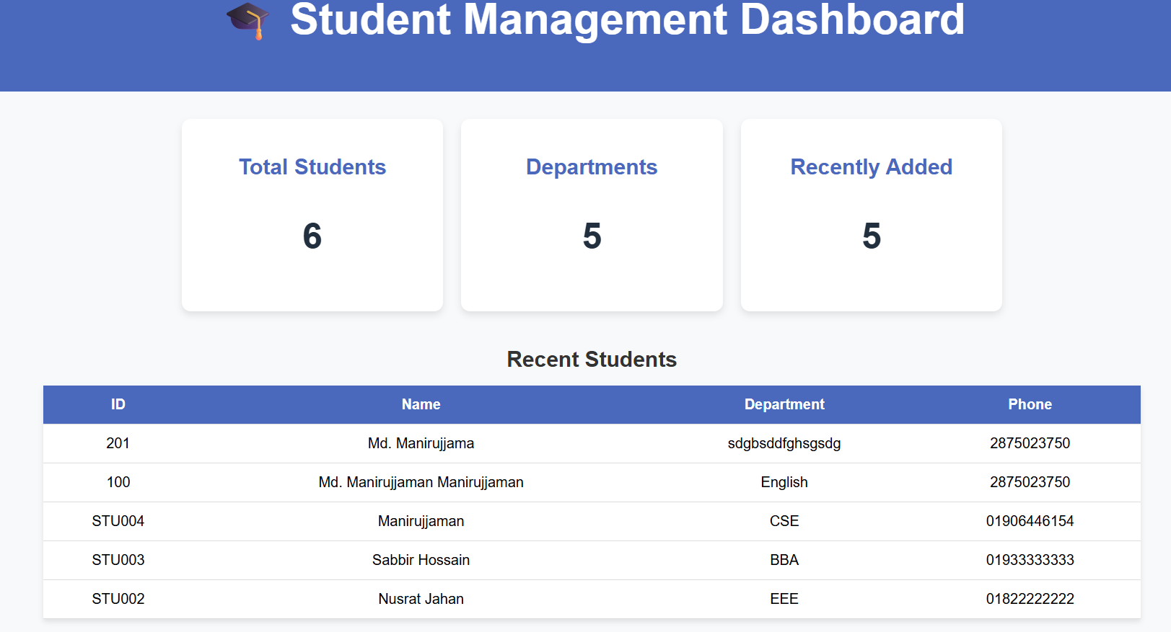

Now it’s time to modify our navbar. We will write the complete navbar code in a separate navbar.html file and include it in our dashboard.html page using Django’s Template Inheritance system ({% include %} or {% extends %}). This approach allows us to reuse the same navbar across multiple HTML pages.
Now create a separate navbar file
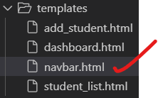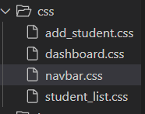
templates/navbar.html
{% load static %}

<!-- Navbar Section Only -->
<link rel="stylesheet" href="{% static 'css/navbar.css' %}">

<nav class="navbar">
<div class="nav-container">
<h1 class="logo">Student Management</h1>

<ul class="nav-links">
<li><a href="{% url 'dashboard' %}">Dashboard</a></li>
<li><a href="{% url 'student_list' %}">Student List</a></li>
<li><a href="{% url 'add_student' %}">Add Student</a></li>
<li><a href="#">Delete Student</a></li>
<li><a href="#">Modify Student</a></li>
</ul>
</div>
</nav>

In static/css/navbar.css:
/* ====== Navbar Styling ====== */

.navbar {
background-color: #1e3a8a; /* deep blue */
padding: 15px 40px;
color: white;
box-shadow: 0 2px 8px rgba(0, 0, 0, 0.15);
position: sticky;
top: 0;
z-index: 1000;
}

.nav-container {
display: flex;
justify-content: space-between;
align-items: center;
flex-wrap: wrap;
}

.logo {
font-size: 22px;
font-weight: bold;
display: flex;
align-items: center;
gap: 10px;
letter-spacing: 0.5px;
}

.nav-links {
list-style: none;
display: flex;
align-items: center;
gap: 30px;
margin: 0;
padding: 0;
}

.nav-links li a {
color: white;
text-decoration: none;
font-weight: 500;
font-size: 16px;
display: flex;
align-items: center;
gap: 6px;
transition: color 0.3s ease, transform 0.2s ease;
}

.nav-links li a:hover {
color: #ffda79;
transform: translateY(-2px);
}

/* ====== Responsive Design ====== */
@media (max-width: 768px) {
.nav-container {
flex-direction: column;
align-items: flex-start;
}

.nav-links {
flex-direction: column;
width: 100%;
gap: 15px;
margin-top: 10px;
border-top: 1px solid rgba(255, 255, 255, 0.2);
padding-top: 10px;
}

.nav-links li a {
font-size: 17px;
}
}

Now remove the navbar section from dashboard.html and include navbar.html in its place using:
{% include 'navbar.html' %}

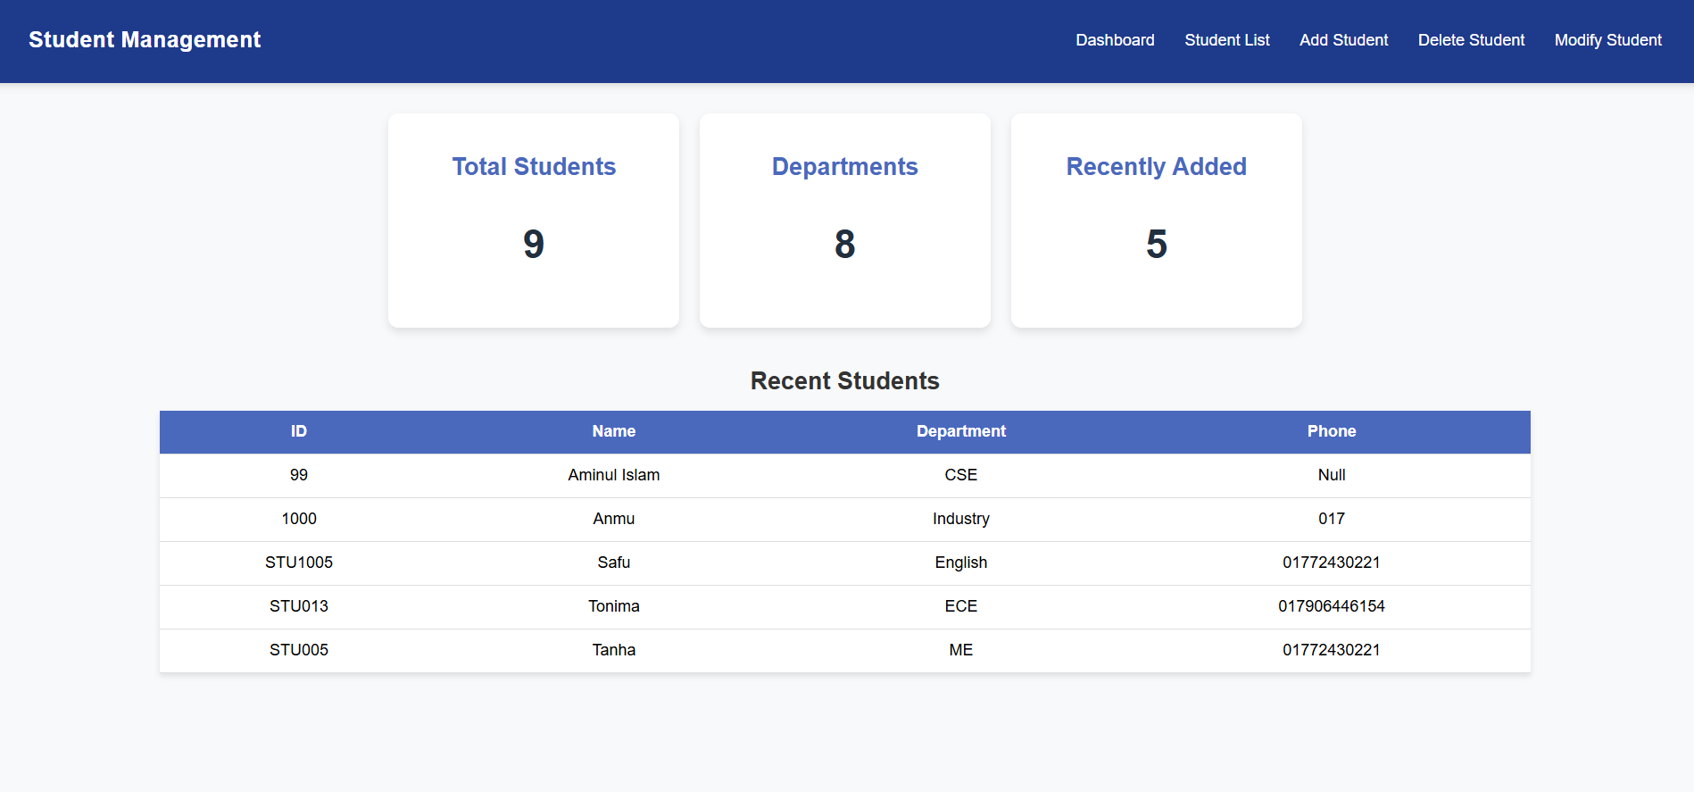
Admin Panel of Django
Django’s admin interface is a powerful built-in tool that automatically generates a management panel from your models. It allows trusted users to easily manage site content. However, it is mainly intended for internal use within an organization, not for building the public front end of a website. It allows developers and administrators to create, read, update, and delete (CRUD) records without writing SQL commands or custom views.
Let’s work with admin panel.
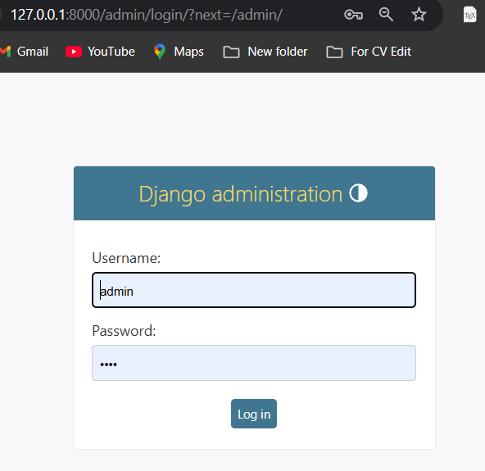

Before accessing the admin panel, let’s create a superuser to log in and manage the Django admin interface. Write following command:
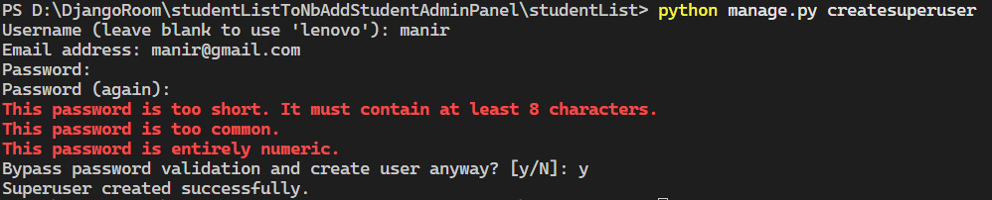
A record is inserted to the table “auth_user” open DB browser and browse your database.
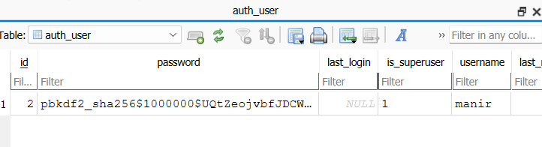
Open Django’s admin panel, and you will see that one user has already been created.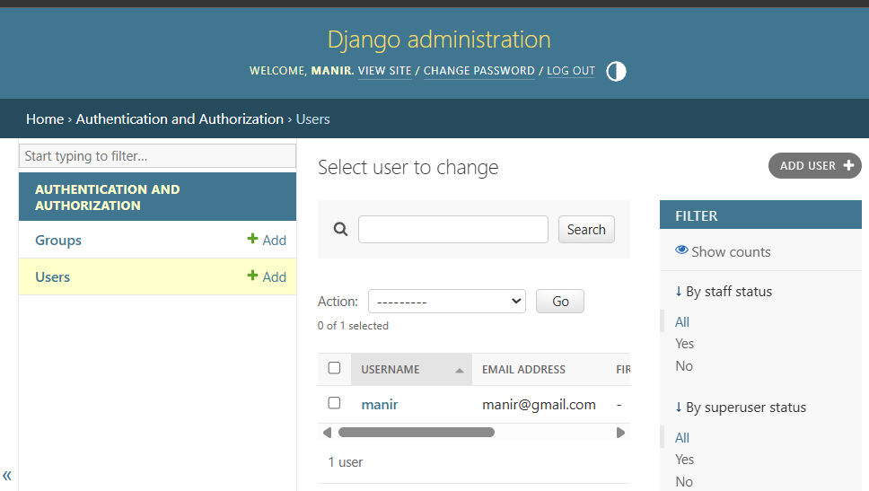
Your project folder structure:
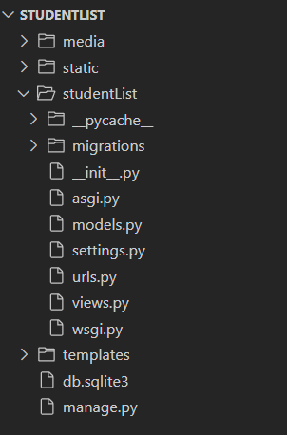

Now let’s create a new ‘app’ set name as ‘adminPanel’ follow given command:
Your folder structure will be like:
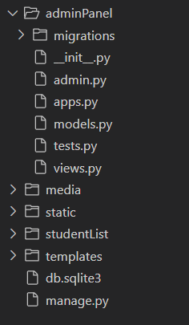
Write the following code inside adminPanel/admin.py:
from django.contrib import admin
# Register your models here.
from studentList.models import Student # import your model
# Register the model so it appears in admin panel
admin.site.register(Student)
Open Django admin panel you will se a table is created in the app ADMINPANEL:
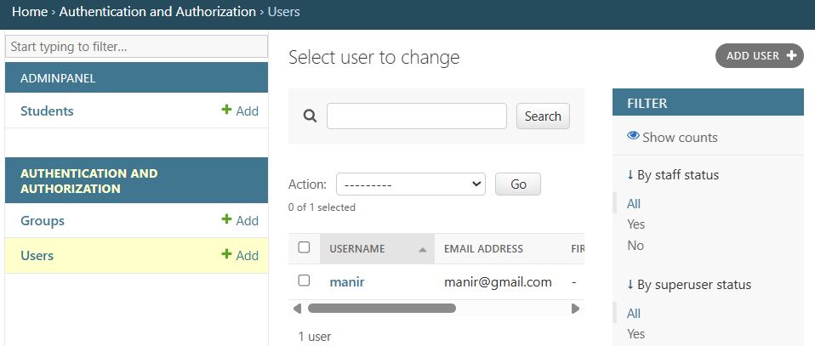
If you want to add student just click on +add and you will get following form now insert data from here and click save.
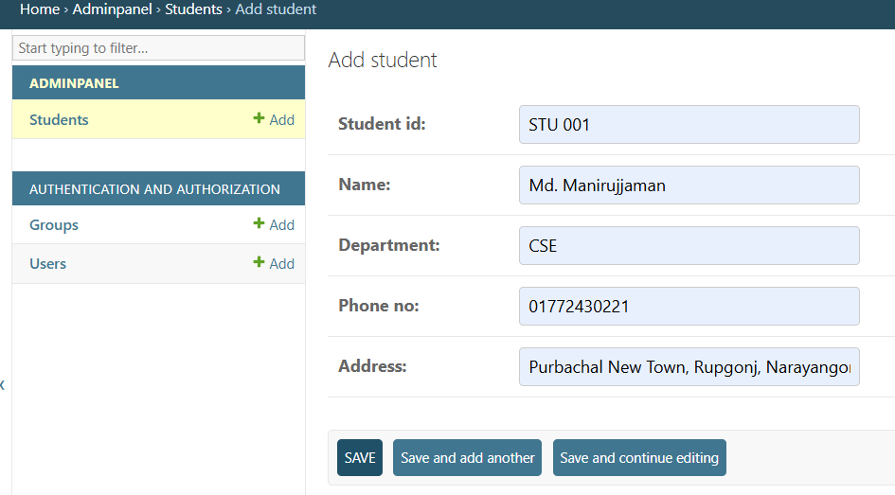

Open studentlist url you will se that data is inserted.

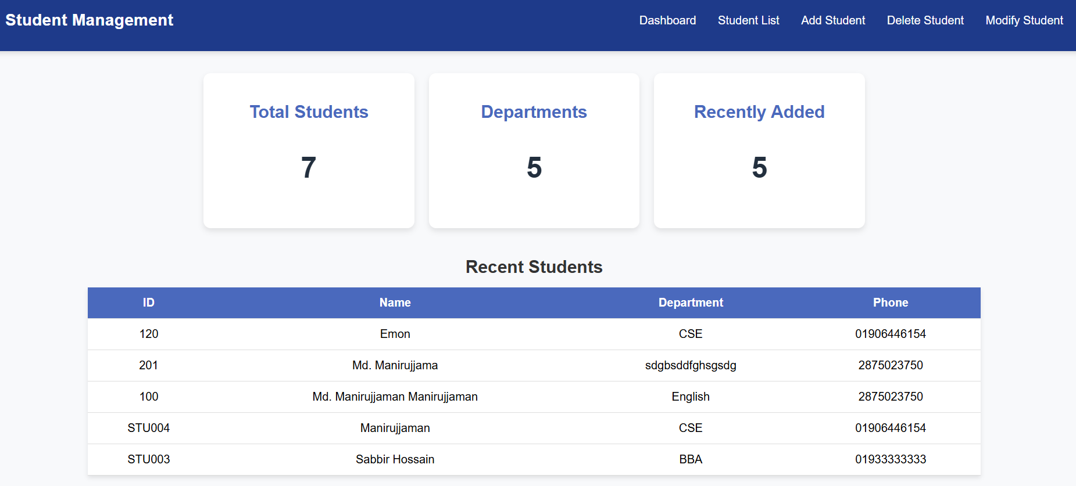
To show selected attributes in admin panel of an table write following changes in admin.py
from django.contrib import admin

from studentList.models import Student

class StudentAdmin(admin.ModelAdmin):
list_display=(
'student_id',
'name',
'department',
'phone_no',
)
admin.site.register(Student,StudentAdmin)
you will see the table in admin panel like as below:
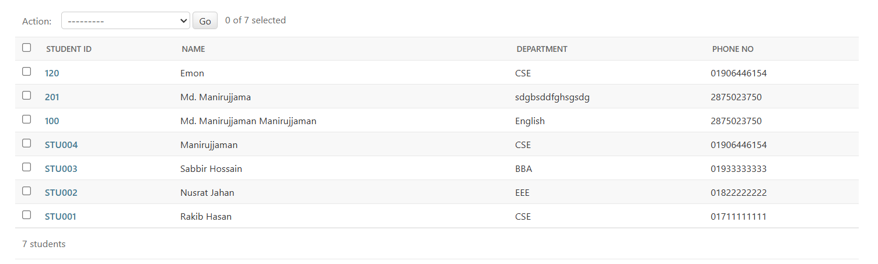
Explain why we created a new adminPanel app instead of using our main studentList app.
To answer this question first of all we need to know why we need apps.
In Django, a project is the overall web application, it contains all the settings, configurations, and apps needed to run your site.An app, on the other hand, is a specific module or component inside that project.
Why we need to create an app in a Django project?
- Modularity (Separation of features)
Each app focuses on a single purpose — like user management, blog, or payment system.
Example:
  - accounts app → handles login, signup, profile
  - blog app → handles posts, comments
  - shop app → handles products, orders
This makes your project organized and easy to maintain.

- Reusability
You can easily reuse an app in another project.
Example: A “contact form” app you built for one project can be copied and plugged into another Django project with little modification.

- Team Collaboration
When multiple developers work together, each person can work on a separate app without affecting others.

- Scalability
As your project grows, you can add or remove apps without changing the whole project structure.

End of Part -02

